Java Message Service (JMS)
The Java Message Service (JMS) API is a messaging standard that allows application components based on the Java Platform Enterprise Edition (Java EE) to create, send, receive, and read messages. It enables distributed communication that is loosely coupled, reliable, and asynchronous.

Message-oriented middleware (MOM) allows sending and receiving messages between distributed systems. Java Message Service (JMS) is a MOM that provides a way for Java programs to create, send, receive, and read an enterprise messaging system's messages.

JMS defines the following concepts:
- JMS provider: An implementation of the JMS interfaces, included in a Java EE implementation.
- JMS client: A Java program that produces and/or receives messages. Any Java EE application component can act as a JMS client.
- JMS message: An object that contains the data transferred between JMS clients. A JMS producer/publisher creates and sends messages. A JMS consumer/subscriber receives and consumes messages.
- Administered objects: Objects created and preconfigured by an administrator. They typically refer to ConnectionFactory and Destination, and are identified by a JNDI name. The ConnectionFactory is used to create a connection with the provider. The Destination is the object used by the client to specify the destination of messages it is sending and the source of messages it is receiving.

JMS supports two messaging models: Point-to-Point and Publish-Subscribe.

A JMS message is composed of three parts:
Header
Properties
Body

ActiveMQ
ActiveMQ is an open source, Java Message Service (JMS) 1.1-compliant, message-oriented middleware (MOM) from the Apache Software Foundation that provides high availability, performance, scalability, reliability, and security for enterprise messaging.

Messaging in Spring
The Java Message Service (JMS) is a standard API for asynchronous messaging.
Synchronous

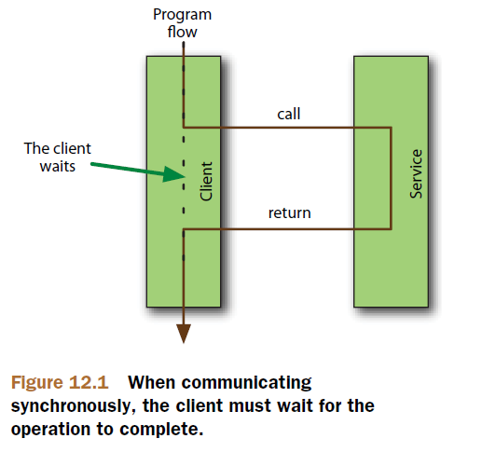

Asynchronous

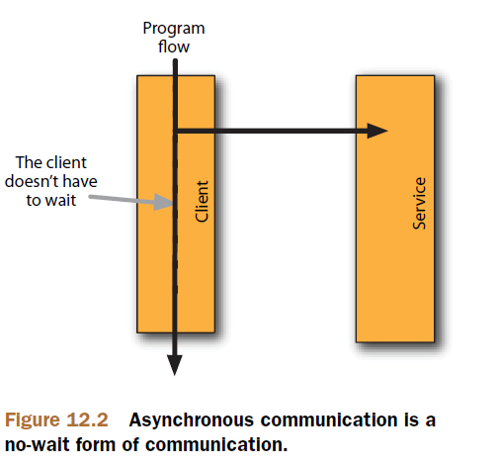

There are two main actors in JMS: message brokers and destinations.
Message brokers = post office system
Destinations = mailboxes where the messages are placed until someone comes to pick them up (without worring about who will pich them up!!).
In JMS, there are two types of destination: queues and topics. Each of these is associated with a specific messaging model, either point-to-point (for queues) or publish-subscribe (for topics).

Queue

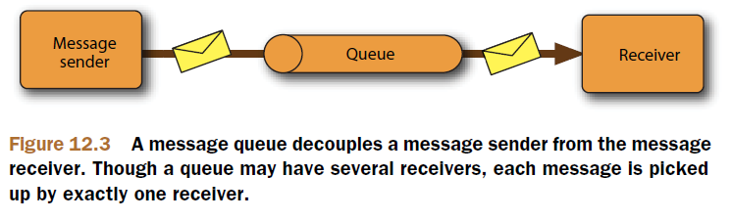

Topic

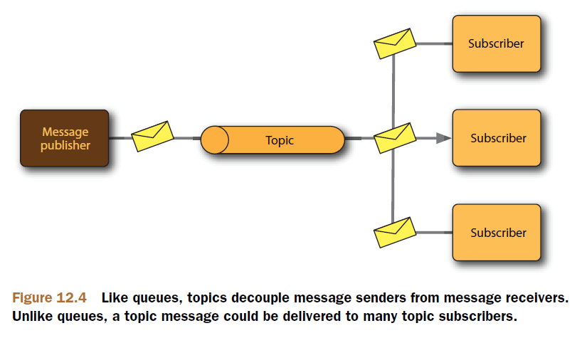

ActiveMQ
ActiveMQ is a great open source message broker and a wonderful option for asynchronous messaging with JMS.

ConnectionFactory
The ConnectionFactory is a JMS specification client side interface for creating connections to a JMS broker. The Broker is a service on the network or embedded in the same JVM which providers the message provider. So think of the ConnectionFactory as the client API for sending and receiving messages and the broker is a server side implementation.
BrokerURL tells the connection factory where the message broker is located.

JmsTemplate
JmsTemplate is used to eliminate boilerplate code. JmsTemplate takes care of creating a connection, obtaining a session, and ultimately sending or receiving messages. This leaves you to focus your development efforts on constructing the message to send or processing the message that are received. What's more, JmsTemplate can handle any clumsy JMSException that may be thrown along the way. If a JMSException is thrown in the course of working with JmsTemplate, JmsTemplate will catch it and rethrow it as one of the unchecked subclasses of Spring's own JmsException.

